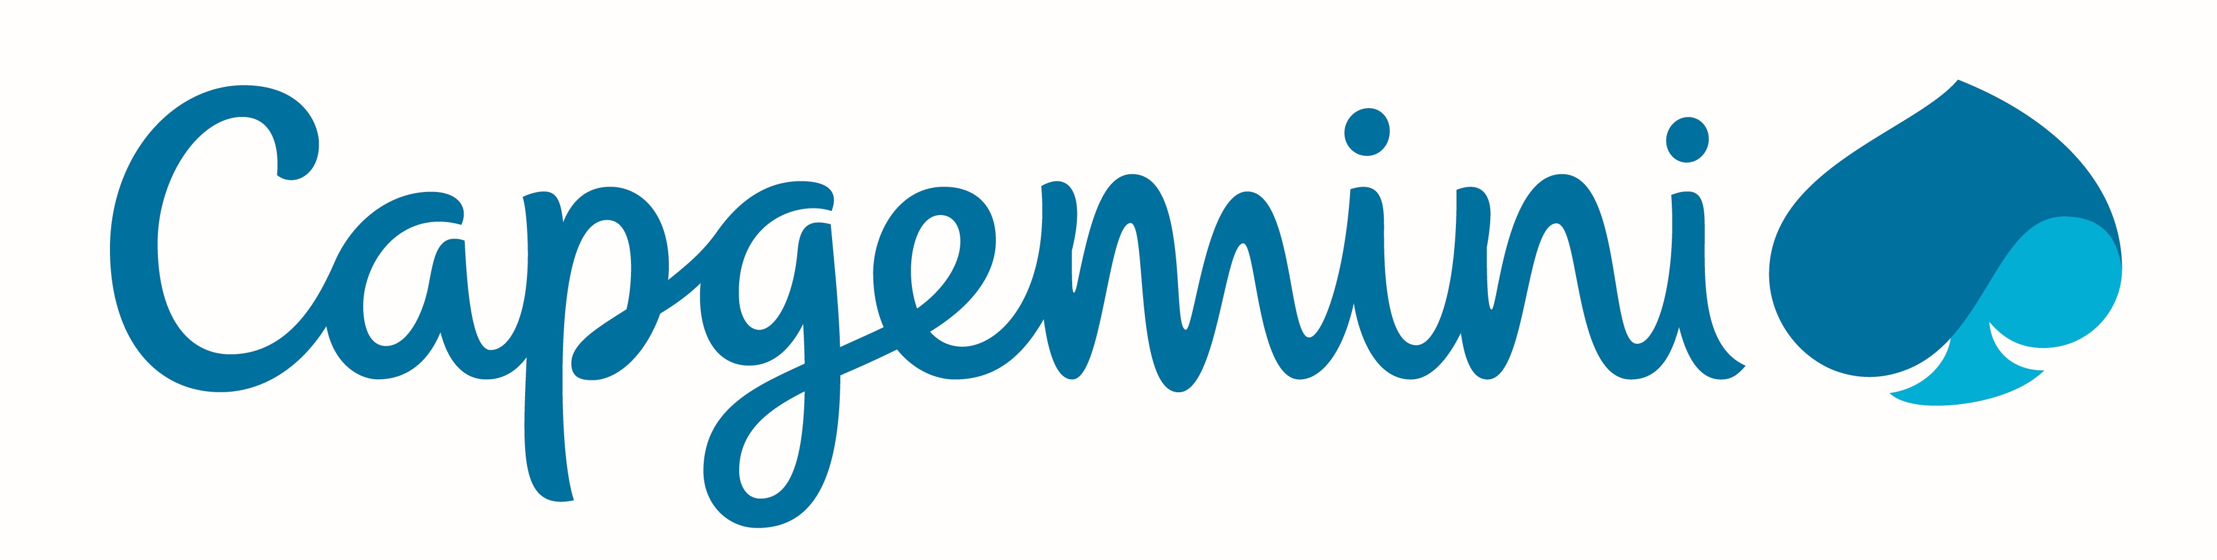

Sneha Awasthi
Professional Summary
Senior Software Engineer with 2+ years of experience in Front-End Development and Mainframe DevOps. Had completed Bachelor of Computer Application(B.C.A.) in 2016. Looking forward for opportunities in the Data Analyst related field.

Skills Profile
Technical
Web Technologies | HTML5, CSS3, Javascipt, AJAX, Jquery, Bootstrap, SASS
Mainframe Technologies | JCL, CICS, COBOL, VSAM
Databases | MongoDB, DB2, MySQL, Oracle
Tools | Git, Jenkins, Visual Studio Code, z/OS Connect, Google Analytics, MS Office, Notepad++
Programming Languages | VBA, Batch Scripting, Basic Python, C
Additional | Excel Macros, VLOOKUP, Pivot Table, Formulas, Charting.

Functional
Training & Development | Soft Skills Training

Professional Experience

SENIOR SOFTWARE ENGINEER
Capgemini, India, September 2016 – Present

- Trained on Mainframe technology for 3 months.
- Worked with ADM Practice for Mainframe, Mainframe DevOps and UI related assignments. The inital assignment was to read customers’ data from VSAM files and then to write them to a different Output VSAM file using Mainframe Technologies like COBOL, JCLand CICS. Then the same files were used with little modification to fetch the data and send it to the API.
- An API was created using z/OS Connect which fetched data from Mainframe and displayed the data on the page when the particular URL was triggered. There were various server side setups which were needed to configure the servers required for usage of z/OS Connect like Liberty server, Angel server, etc.
- Also worked on the UI development part which included the use of Web technologies like HTML, CSS, Javascript, AJAX. The UI was created to display the details of one specific SSN in a tabular format. The SSN was to be entered in the search field and after submission, the API was triggered which “GET” the data to the webpage using AJAX. The data was systematically displayed.
- The entire process was automated using Jenkins – a CI tool.
- Contributed towards coding Batch scripts (.bat files) for easing the file transfers and other basic functionalities between Mainframe and Windows.
- Also used Excel Macros along with VBA for automation for a small project.

Training and Seminars
- Attended IBM conference in October 2018 that gave us details about upcoming IBM innovations including IBM z/OS Connect, IBM Zowe, etc.
- Attended IBM Developer Connect Lite at Pune in 2017 which introduced us to IBM Watson, IBM Cloudant, IBM Bluemix, etc.
- Received IDz/RDz Remote Training Sessions.
- Received training on Mainframe Technology for 3 months.
- Attended Seminar on Cyber Security at the college campus.

Certifications
- Google Analytics for Beginners
- IBM Certified Database Associate-DB2-9 Fundamentals
- Cyber Security Certification by Intelligent Quotients.

Education
- IMED, Pune, BVP University, B.C.A., 2016 – 78%
- Mithibai College, Mumbai, Maharashtra State Board, XII, 2013 - 61%
- Lokhandwala Foundation School, Mumbai, ICSE, X, 2011 – 87%

